

THe world’s fear

A game dev document



September 6, 2019

Tom van Kaathoven, Wiebe van Herwijnen

I

Contents

Introduction: 2

goal: 2

the world: 2

unique selling points: 2

Risk spots: 2

Character generation/Hard reset: 2

Renown fear: 2

One Page GDD: 3

Conclusie: 4

# Introduction:

The genre we would like to make a game in, is roguelike. We want to make a game that has a simple movement set, but a very fast paced combat system. The player spawn in as townsfolk hero who volunteered to safe his hometown from “the devourer”.

## goal:

The final goal of a player is to defeat the devourer who threatens your town. To get to this goal, you need to defeat his minions in order to get to him. The further you hack through his ranks, he concludes that he will have trouble defeating the player.

## the world:

The devourer has burned and eaten away large chunks from the world. This makes the world very small, only the hometown of the hero is left. The further you wander off from town, the deadlier the monsters become.

# unique selling points:

## Risk spots:

The boss in the game has attack pattern which are outlined just before he strikes, there is also a Golden outline which is called: “the risk spot”. If you manage to enter the risk spot right on time you can deal damage back to the boss. This makes for a hard encounter in which you can choose to play safe or defeat the boss faster by standing in the risk spots.

## Character generation/Hard reset:

When the player’s hero dies, a new hero will arise from the town. The new hero has different stats then the one who just got killed. Maybe the first hero was a flimsy boy with a lot of agility, and this time it is a man with a lot of strength.

## Renown fear:

In this game we decided to work with a new mechanic called: Renown fear. Renown helps with defeating the boss as he heard how you slaughtered their hordes. Renown fear gives all sorts of debuffs to the “the devourer”. For example, lower HP. You can earn renown by defeating the henchman of the “the devourer”

# how do the uniqe selling points work TOGETHER?

# One Page GDD:

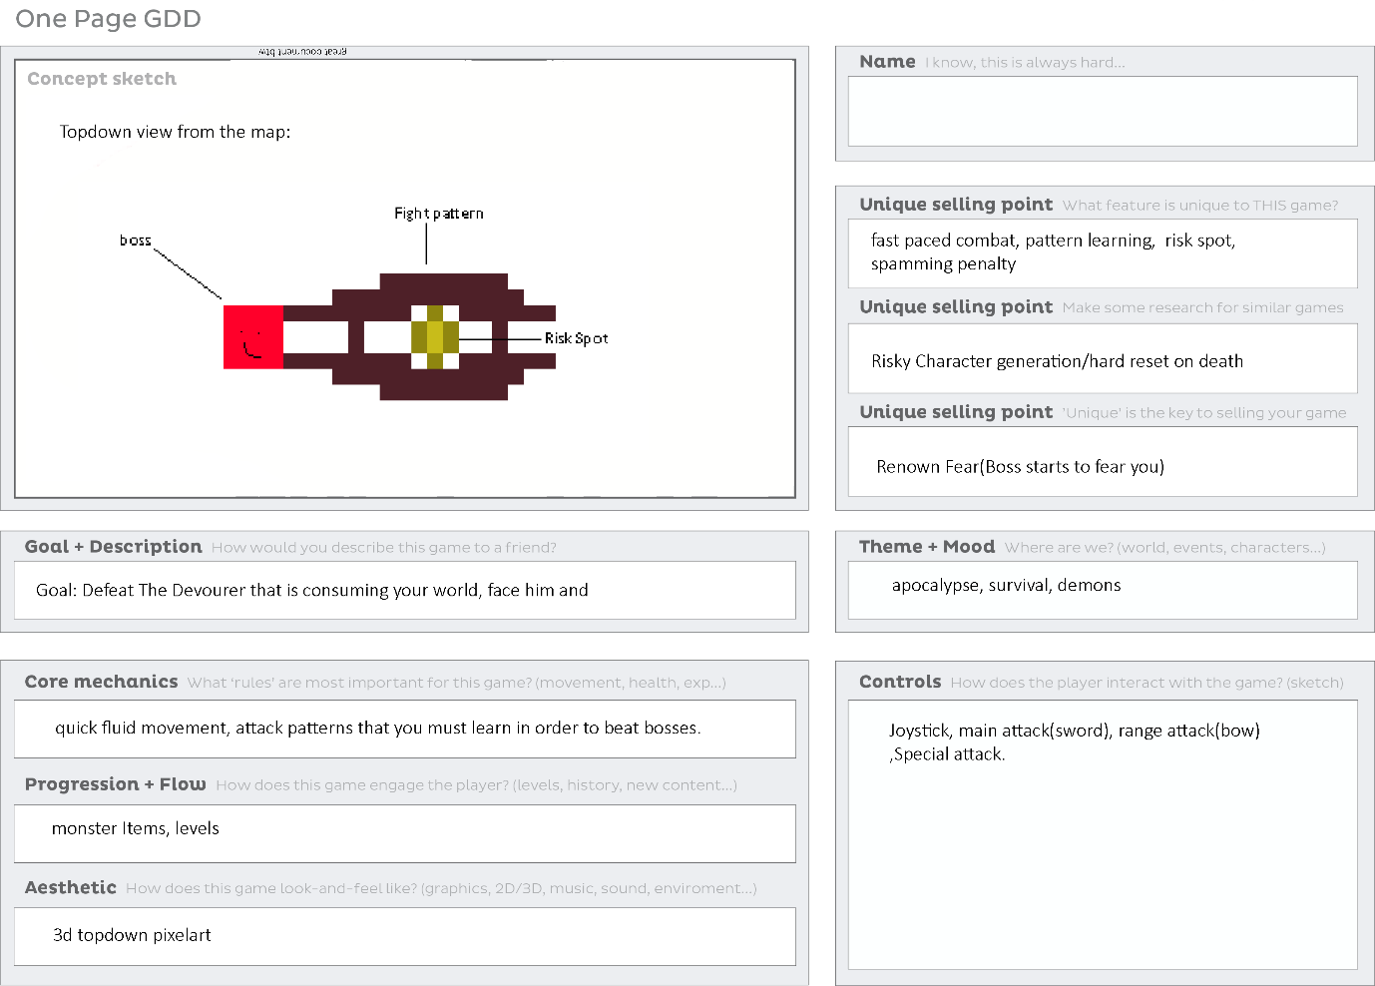

# ripp oof euuhm inspiratie games(definitely):

## HyperLight drifter:

Hyperlight is a fast-paced game that works with a lot of dashes and several simple basic moves for example slicing with your sword. Together with a dash that can be used quite often you can preform several attacks without getting hit by the enemy that your facing.

What makes this great, is that you are very limited on health in this game which forces you to dodge all sorts of attacks. So, if you are able to pull of fights without receiving any damage, it feels satisfying and you feel like you are good at the game.

## Darksouls:

Darksouls inspired us by their way of dying. The hard reset is a very rewarding system in which a player can truly shine. The system they work with is that that you gather souls by slaying enemies, and when you die by one of their blades, you lose half of your points. The points you lose are used to level your character up. So when you die your character has insufficient points for levelling up.

## Sekiro:

This game is made by the same developers as darksouls. This is visible in their level design but not in the mechanics. Sekiro’s death mechanic punished as hard as that of dark souls, but in a different way. In Sekiro you have a lot of NPC that help you progress in the game, every time you die, there is a chance one of them gets sick. When they are sick and you keep dying, they eventually can die making buying items from them not possible.

# Conclusie:

With our game we want to make the player feel: skilled, smart, challenged and rewarded. We want to give the player fun with the challenge the game provides. Because of the hard resets the player doesn’t want to die, this is where the smart part comes in and why it will give you a blast when you barely survive a fight. Does the player want to play risky and be rewarded? or does he want to play safe and slowly gather more strength? The choice is up to the player.